**iNeuron_SQL_Master_Project Completed**

**A**𝗻𝗮𝗹𝘆𝘇𝗶𝗻𝗴 𝗥𝗼𝗮𝗱 𝗦𝗮𝗳𝗲𝘁𝘆 𝗶𝗻 𝘁𝗵𝗲 𝗨**K**

𝗕𝘂𝘀𝗶𝗻𝗲𝘀𝘀 𝗽𝗿𝗼𝗯𝗹𝗲𝗺:

The UK Department of Transport provides open datasets on road safety and casualties, and one can use these datasets to analyze how safe the roads in the UK are. This project will help you answer a few questions using their 2015 dataset. The dataset has 3 tables

i.e Accident, vehicle, Vehicle_type

𝗔𝗽𝗽𝗿𝗼𝗮𝗰𝗵/𝗣𝗿𝗼𝗷𝗲𝗰𝘁 𝗜𝗱𝗲𝗮

Use aggregate functions in SQL and Python to answer the following sample questions:

1. Evaluate the median severity value of accidents caused by various Motorcycles.

2. Evaluate Accident Severity and Total Accidents per Vehicle Type

3. Calculate the Average Severity by vehicle type.

4. Calculate the Average Severity and Total Accidents by Motorcycle.

**ANSWER :-**

create database Accidents ;

use Accidents ;

==================================================================================

CREATE TABLE accident(

accident_index VARCHAR(13),

accident_severity INT

);

CREATE TABLE vehicles(

accident_index VARCHAR(13),

vehicle_type VARCHAR(50)

);

CREATE TABLE vehicle_types(

vehicle_code INT,

vehicle_type VARCHAR(10)

);

LOAD DATA LOCAL INFILE 'C:\\Study\\INueron Data Analyst\\Mysql\\Projects\\assignment and projects completed\\iNeuron_SQL_Master_Project Completed\\Project 1\\Datasets\\Accidents_2015.csv'

INTO TABLE accident

FIELDS TERMINATED BY ','

ENCLOSED BY '"'

LINES TERMINATED BY '\n'

IGNORE 1 LINES

(@col1, @dummy, @dummy, @dummy, @dummy, @dummy, @col2, @dummy, @dummy, @dummy, @dummy, @dummy, @dummy, @dummy, @dummy, @dummy, @dummy, @dummy, @dummy, @dummy, @dummy, @dummy, @dummy, @dummy, @dummy, @dummy, @dummy, @dummy, @dummy, @dummy, @dummy, @dummy)

SET accident_index=@col1, accident_severity=@col2;

LOAD DATA LOCAL INFILE 'C:\\Study\\INueron Data Analyst\\Mysql\\Projects\\assignment and projects completed\\iNeuron_SQL_Master_Project Completed\\Project 1\\Datasets\\Vehicles_2015.csv'

INTO TABLE vehicles

FIELDS TERMINATED BY ','

ENCLOSED BY '"'

LINES TERMINATED BY '\n'

IGNORE 1 LINES

(@col1, @dummy, @col2, @dummy, @dummy, @dummy, @dummy, @dummy, @dummy, @dummy, @dummy, @dummy, @dummy, @dummy, @dummy, @dummy, @dummy, @dummy, @dummy, @dummy, @dummy, @dummy, @dummy, @dummy, @dummy, @dummy, @dummy)

SET accident_index=@col1, vehicle_type=@col2;

LOAD DATA LOCAL INFILE 'C:\\Study\\INueron Data Analyst\\Mysql\\Projects\\assignment and projects completed\\iNeuron_SQL_Master_Project Completed\\Project 1\\Datasets\\vehicle_types.csv'

INTO TABLE vehicle_types

FIELDS TERMINATED BY ','

ENCLOSED BY '"'

LINES TERMINATED BY '\n'

IGNORE 1 LINES;

Select * from Accident

Select * from vehicles

Select * from vehicle_types

==================================================================================

1. **Evaluate the median severity value of accidents caused by various Motorcycles. ( MYSQL and PYTHON )**

**In SQL Create a New Table :  
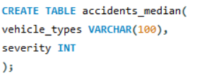**

**In Python write these code :**

1. **Install required Libraries**



1. **Connect Python to MySQL and write these codes**

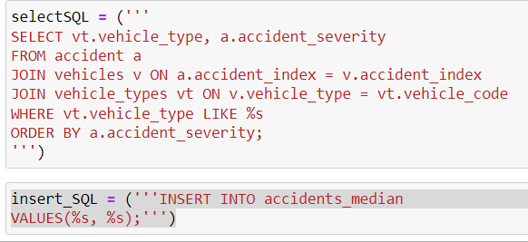

**Now check in MySQL what value is inserted into the table which we have created :**



==================================================================================

1. **Evaluate Accident Severity and Total Accidents per Vehicle Type**

select vt.Vehicle_Type as 'Vehicle Type', a.accident_severity as 'Severity', COUNT(v.vehicle_type) AS 'Number of Accidents'

from accident a

JOIN Vehicles v ON a.accident_index = v.accident_index

JOIN Vehicle_Types vt ON v.vehicle_type = vt.vehicle_code

Group by 1

Order by 2 ;  
  
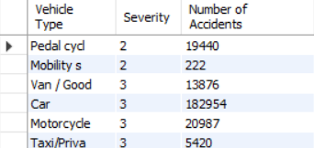  
  
===========================================================================

**3. Calculate the Average Severity by vehicle type.**

select vt.Vehicle_Type as 'Vehicle Type', avg(a.accident_severity) as 'average severity' from accident a

JOIN Vehicles v ON a.accident_index = v.accident_index

JOIN Vehicle_Types vt ON v.vehicle_type = vt.vehicle_code

Group by 1

Order by 2 ;  
  
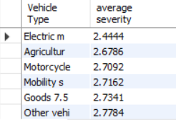  
===========================================================================

**4. Calculate the Average Severity and Total Accidents by Motorcycle.**

select vt.Vehicle_Type as 'Vehicle Type', avg(a.accident_severity) as 'average severity' from accident a

JOIN Vehicles v ON a.accident_index = v.accident_index

JOIN Vehicle_Types vt ON v.vehicle_type = vt.vehicle_code

Group by 1

HAVING vt.Vehicle_type = 'motorcycle'

Order by 2 ;

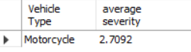

======================================================================================================================================================

𝗔𝗻𝗮𝗹𝘆𝘇𝗶𝗻𝗴 𝘁𝗵𝗲 𝗪𝗼𝗿𝗹𝗱 𝗣𝗼𝗽𝘂𝗹𝗮𝘁𝗶𝗼**n**

**(NOTE :- In the Source section** [**https://github.com/ptyadana/SQL-Data-Analysis-and-Visualization-Projects**](https://github.com/ptyadana/SQL-Data-Analysis-and-Visualization-Projects) **dataset is not found. So I’ve taken CIA population data from (source :-** [**https://www.openintro.org/data/index.php?data=cia_factbook**](https://www.openintro.org/data/index.php?data=cia_factbook) **) (CSV). In this CSV, ‘ID’ and ‘code’ columns are not found so, I’ve replace ‘ID’ with ‘country’. The data has information from only 259 different countries)**

In this project, you will use the dataset by CIA World Factbook and explore how the world population spreads across different countries.  
  
The data has information from only 261 different countries. Dataset contains 11 rows and 262 columns like id, code, area, population, birth_rate, death_rate, migration_rate, population_growth.

𝗔𝗽𝗽𝗿𝗼𝗮𝗰𝗵/𝗣𝗿𝗼𝗷𝗲𝗰𝘁 𝗜𝗱𝗲𝗮

You will learn how to use SQL to answer the following analytical questions:

1. Which country has the highest population?
2. Which country has the least number of people?
3. Which country is witnessing the highest population growth?
4. Which country has an extraordinary number for the population?
5. Which is the most densely populated country in the world?

**ANSWER :-**

Create database CIA_World_Factbook ;

use CIA_World_Factbook ;

create table World_Population (

Country Varchar(30),

Area decimal(38,2),

Birth_Rate decimal(38,2),

Death_Rate decimal(38,2),

Migration_Rate decimal(38,2),

population int ,

population_growth_rate decimal(38,2)

);

LOAD DATA LOCAL INFILE 'C:\\Study\\INueron Data Analyst\\Mysql\\Projects\\assignment and projects completed\\iNeuron_SQL_Master_Project Completed\\Project 2\\Datasets\\cia_factbook.csv'

INTO TABLE World_Population

FIELDS TERMINATED BY ','

ENCLOSED BY '"'

LINES TERMINATED BY '\n'

IGNORE 1 LINES

(@col1, @col2, @col3, @col4, @dummy, @dummy, @dummy, @dummy, @col5,@col6, @col7)

SET Country=@col1, Area=@col2, Birth_Rate=@col3, Death_Rate=@col4, Migration_Rate=@col5,population=@col6, population_growth_rate=@col7;

select * from World_Population;

==================================================================================

**1. Which country has the highest population?**

select country , population from World_Population

order by population desc

limit 1;

OR

SELECT country, population FROM World_Population WHERE population = (SELECT MAX(population) FROM World_Population)



==================================================================================

**2. Which country has the least number of people?**

SELECT country, population FROM World_Population WHERE population = (SELECT MIN(population) FROM World_Population)



==================================================================================

**3. Which country is witnessing the highest population growth?**

select country , population_growth_rate from World_Population

order by population_growth_rate desc

limit 1;

OR

SELECT country, population_growth_rate FROM World_Population WHERE population_growth_rate = (SELECT MAX(population_growth_rate) FROM World_Population)



==================================================================================

**4. Which country has an extraordinary number for the population?**

?

==================================================================================

**5. Which is the most densely populated country in the world?**

select country, area, population, (population/area) as 'population density' from World_Population

order by (population/area) desc

limit 1;



